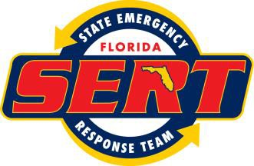**SITUATION REPORT No. 44**

Hurricane Irma – DR 4337

# The Florida State Emergency Response Team October 19, 2017 - Published at 1200

State Emergency Operations Center Activation Level: 3 Information Current as of 1200 October 19, 2017

# *Updated Information in Red*

## IMPORTANT INFO MESSAGES

|  |  |  |  |
| --- | --- | --- | --- |
| 42 | FDEP Pre-authorized list of Debris Management Sites | 1403 | DRC Status Report |
| 96 &  97 | Insurance Information/Guidance to Recovery | 1524 | Request for Housing Strategy (County Input) |
| 125 | D-SNAP Information | 1531 | Recovery County Call Briefing Slides |
| 730 | DR-4337 Declaration and Amendments | 1537 | TSA Participating Hotel Guidance |
| 970 | Debris Information Clearinghouse | 1571 | IHP Report (FEMA Numbers by County) |
| 1216 | Public Assistance Program & Policy Guide (PA PPG) 2017 | 1573 | TSA Report |
| 1281 | Request for Public Assistance Submittal Instructions | 1607 | New Hurricane Irma Recovery Jobs Portal |
| 1344 | Transitional Sheltering Assistance Information | 1621 | Private Property Debris Removal |
| 1402 | DEM Debris Website Reporting Link | 1625 | Public Assistance “New Model” Overview |

**PUBLIC ASSISTANCE PROGRAM**

(AS of 10.17.2017)

PA Categories A-G

* Counties approved: 55 Request for Public Assistance (RPAs)
* Received by State: 792
* Under State Review 80
* Submitted to FEMA: 712
* Under FEMA Review: 244
* Approved by FEMA: 468 (In Phase I)

**Private Property Debris Removal Requests**

(As of 10.17.2017)

* Received by State: 88
* Under State Review: 6
* Submitted to FEMA: 82
* Under FEMA review: 53

## INDIVIDUAL ASSISTANCE

The enterprise data warehouse is still experiencing delays in updating reporting information.  In lieu of the IA Daily Status Report, we are providing the attached live update and the information below.

## As of 10.19.2017

Total Registrations: 2,528,183

Total IHP Approved: $796,859,890.00

Total Housing Approved: $540,419,884.35

Total ONA Approved: $256,440.005,65

**DRCs**

As of 10.19.2017

*Fixed Sites 13 Mobile Sites 8 Pending Sites 6 (Waiting on Inspections)*

**DSA Totals**

TOTAL DSA IN FIELD **-** 674

CREWS 78

FEMA Corps. 23 (115 members)

Strike Teams 4

Surge Personnel 395

FEMA Personnel 130

**Daily Cumulative**

**HOME VISTS:** 5,106 129.142

**SURVIVOR INTERACTIONS:** 3,565 105,313

**SURVIVOR REGISTRATIONS:** 226 24,544

**CASE UPDATES:** 143 9,229

**CASE INQUIRIES:** 419 13,804

**Branch l:**

In coordination with the Local, State and Federal partners, the following County Completion schedule is as followed:

**All counties** are in County Completion

**Branch ll:**

In coordination with the Local, State and Federal partners, the following County Completion schedule is as followed:

**Baker, Gilchrist, Nassau, Union, Bradford Counties** are now in the process of County Completion.

**Branch III**: In coordination with the Local, State, and Federal partners, the following County Completion

**Schedule is as Followed:**

**Hillsborough County** is now in County Completion

**Orange County** is now in County Completion – DSA’s are now in DRC’s

**Indian River County** is now in County Completion

**Osceola County** is now in County Completion

**Pasco County** is now in the process of County Completion

**Pinellas County** is now in the process of County Completion

**Polk County** is now in the process of County Completion

## Mass Care

**Shelters**

As of 0700 10/17/17 1 shelter is operating with a population of 96 in Lee County

<http://www.floridadisaster.org/shelters/summary.aspx>

* Multi-Agency Shelter Transition Teams (MASTT) continue to coordinate with local community leaders, Emergency Managers and FEMA Branch/Division representatives to assess emerging shelter requirements progress on shelter consolidations and closures.
* MASTT is coordinating with ARC case workers on deliberate efforts to close the remaining ARC-managed shelter.
* Staff is working with Housing to make sure there is a link from MC to temporary or permanent housing solutions.
* Staff continued to refine reporting protocols for Multi-Agency Shelter Transition (MAST) field teams to capture more granular information on barriers to survivor’s progress, and provide a clearer picture of outcomes.
* Shelter posted to close noon Saturday 10/21/2017, Red Cross will only allow current shelter residents to utilize the shelter

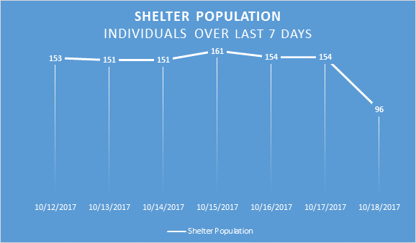

**Transitional Sheltering Assistance**

|  |  |  |
| --- | --- | --- |
| **TSA # as of 10/19/17 at 0700** | | **+/- change** |
| Total households eligible: | 795,280 | +3,900 |
| Households checked in: | 11,427 | +7 |
| Total population in TSA hotels: | 26,985 | +23 |
| Rooms currently occupied: | 12,242 | +12 |
| Hotels currently utilized: | 899 | -2 |

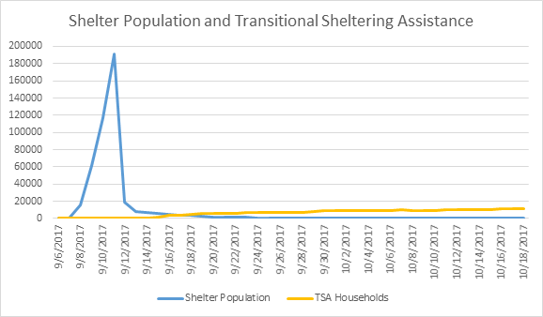

|  |  |  |  |  |  |  |  |  |  |  |  |  |
| --- | --- | --- | --- | --- | --- | --- | --- | --- | --- | --- | --- | --- |
|  | | | | **FEMA Call Outs 10/18/17 0700** | | | | |  | | | |
| **Total Applicants** | | **Total Apps Called** | | | | | **Total Calls** | **Total Completed** | | | **Total To Call** | |
| 15,407 | | 1,520 | | | | | 3,152 | 813 | | | 14,539 | |
|  |  |  |  | |  |  |  |  | |  |  |  |
| **Complete - Interview Complete** | **Completed - No More Attempts Scheduled** | | | | | **To Call - Attempted, Not Contacted** | | **To Call - No Attempts Made** | | | **To Call - Partial Interview** | |
| 681 | 132 | | | | | 637 | | 13,887 | | | 15 | |
|  |  |  |  |  |  |  |  |  |  |  |  |  |

* FEMA Call staff members are currently making call outs using the Call-Out and Review System (CARS) CARS will attempt to collect more aggregate information applicant status, and additional information on transportation and feeding unmet needs.
* Staff continue to work the large number of information requests on TSA from verifying household eligibility to hotels not in system or the appearance that they are not accepting TSA individuals.
* Staff currently working on individuals that are appealing their ineligibility decision for TSA
* Provided 69 referrals, performed 53 case updates, submitted 9 requests for reasonable accommodations, filed 5 hotel incident reports, identified 5 permanently housed and made 61 calls attempts for those in TSA as of COB on 9/17/2017

**MASTT:**

* MASTT lead attended meetings with American Red Cross and Lee County Emergency Management to discuss available county resources (limited) and social services staffing capacity at shelter (limited) and compare FEMA registrations with ARC shelter registrations and ARC casework intakes.
* Multi-Agency Shelter Transition Teams (MASTT) continued field work in coordination with branch leadership and local officials.
* Information updates coordinated with IA liaisons and Direct Housing
* Support Multi-Agency Resource Center at shelter Tuesday 10/17/17 and Wednesday 10/18/17
* Regular food assistance recipients who live in the 48 counties approved for D-SNAP will have their household allotment increased to the maximum for September and October to bring them up to the total amount they would have received from D-SNAP.
* Feeding Florida has been providing food packages for those in a presidentially declared disaster county. Each food package contains 10 to 20 food items that can be taken home and prepared as needed. Each of the packages contain 25-30 pounds of shelf-stable food items. Normal operation and distribution of The Emergency Food Assistance Program (TEFAP) has resumed within the Feeding Florida network. Contact them for food pantry/congregate feeding locations
* Four trucks of 30 lb. food boxes are in transit to Feeding Florida to support long term feeding for those in TSA and other locations that limit traditional feeding mechanisms as of 10/16/2017.

**Distribution of Emergency Supplies**

* Distribution of Emergency Supplies is transitioning to an as needed basis. No fixed bulk distribution sites in operation.
* American Red Cross has provided 39,493 (+1) cumulative clean-up kits, 11,110 (0) comfort kits and 977,411 (+9) bulk items through 10/17/17.
* The Salvation Army has provided 1,421 (+0) cleanup kits, and 9,669 (+0) hygiene kits, and 225,184 (+0) bulk items through 10/9/17.

**FEMA - Meetings and Coordination**

Mass Care and Emergency Assistance continues coordination with Direct Housing, Human Services, the Individuals and Households Program, Voluntary Agency Liaisons, the Unmet Needs Task Force, State and voluntary counterparts to maintain situational awareness and assist regarding mass care and emergency assistance, disaster specific and Puerto Rican evacuees.

* Coordinating with FL ESF #18 Business, Industry and Economic Stabilization for outreach to hotels through Visit Florida and the Florida Restaurant and Lodging Association to identify where events may impact vacancies to report this week.
* Respond to Congressional, Gubernatorial and other informational requests

*Direct Housing Task Force Stand-up*: Address ongoing activities relating to housing and update on current shelter and TSA status

*Housing Recovery Support Function (RSF):* Monitor for long term housing strategies, goals and concerns as survivors’ transition frommass care programs to longer term housing solutions

*Lee County Shelter Transition*: Discussion of shelter population, aggregate demographics and TSA program and long term shelter transition and recovery strategy. The MARC has assisted households in recovery planning.

*RSS Coordination Call (Hurricane Harvey & Hurricane Irma)*: Monitor to evaluate scope of FEMA resources and commitments as may impact Mass Care and Emergency Assistance

*State Recovery Call:* Review of recovery functions and monitor for ongoing issues and concerns

*Survivor Assistance Task Force:* Discussion of unmet needs and service locations across the state

*Transitional Sheltering Assistance Coordination*: Share best practices and workarounds due staffing limitations and technological constraints between DR-4332-TX, DR-4337-FL, and DR-4334-CA

**Feeding Task Force**

|  |  |
| --- | --- |
| **Feeding on 10/17/17 at 1700** | |
| Meals Served: | 190 |
| Snacks served: | 893 |
| Total Mobile Kitchens: | 0 |

* The American Red Cross has provided 726,217 meals and 487,461 snacks through 10/17/2017. They intend to cease feeding 10/21/2017 to coincide with the end of the sheltering mission.
* The Salvation Army has provided 277,947 meals, 416,808 drinks, and 284,291 snacks through 10/09/17 and has ceased hot feeding. Support is now processed through local facilitation.
* Disaster Supplemental Nutrition Assistance Program approved for 48 counties congruent with the individual assistance declarations (Baker, Brevard, Broward, Charlotte, Clay, Collier, Columbia, Desoto, Dixie, Duval, Flagler, Gilchrist, Glades, Hardee, Hendry, Hernando, Highlands, Hillsborough, Indian River, Lafayette, Lee, Levy, Manatee, Marion, Martin, Miami-Dade, Monroe, Nassau, Okeechobee, Orange, Osceola, Palm Beach, Pasco, Polk, Putnam, Sarasota, Seminole, St. Johns, St. Lucie, Suwanee, and Volusia). Food for Florida pre-registration will be available on the Food for Florida website and open for people in need of food assistance in eligible counties through October 30.
  + Food for Florida sites are currently operating for Palm Beach, Pasco, and Polk counties. For shorter lines access it is recommended applicants pre-register and attend in their county on the date matching the end first initial of their last name
* Regular food assistance recipients who live in the 48 counties approved for D-SNAP will have their household allotment increased to the maximum for September and October to bring them up to the total amount they would have received from D-SNAP.
* Feeding Florida has been providing food packages for those in a presidentially declared disaster county. Each food package contains 10 to 20 food items that can be taken home and prepared as needed. Each of the packages contain 25-30 pounds of shelf-stable food items. Normal operation and distribution of The Emergency Food Assistance Program (TEFAP) has resumed within the Feeding Florida network. Contact them for food pantry/congregate feeding location

[DSNAP Sites](http://www.dcf.state.fl.us/programs/access/fff/siteLocations.shtml) 10/19/17 0700-1800

Dixie Co. - *Suwannee River Fairgrounds Pavilion*17851 NW 90th Ave Fanning Springs, FL, 32693 (Surname A-F)

Gilchrist Co. - Suwannee River Fairgrounds Pavilion 17851 NW 90th Ave Fanning Springs, FL, 32693 (Surname A-F)

Levy Co. - *Suwannee River Fairgrounds Pavilion*17851 NW 90th Ave Fanning Springs, FL, 32693 (Surname A-F)

Palm Beach Co. –  *John Prince Memorial Park* [4759 S. Congress Ave., Lake Worth, FL 33461](https://www.google.com/maps/place/4759+S+Congress+Ave,+Lake+Worth,+FL+33461/@26.6060501,-80.0916967,17z/data=!3m1!4b1!4m5!3m4!1s0x88d8d870541abdb9:0xeb641843a3e8f9c0!8m2!3d26.6060501!4d-80.089508) (Surname K-O)

Palm Beach Co. –  *Lake Ida West Park* [1455 Lake Ida Road, Delray Beach, FL 33444](https://www.google.com/maps/place/1455+Lake+Ida+Rd,+Delray+Beach,+FL+33444/@26.4708209,-80.0897889,17z/data=!3m1!4b1!4m5!3m4!1s0x88d8dff27386ac91:0x17167d14a530e9b6!8m2!3d26.4708209!4d-80.0876002) (Surname K-O)

Palm Beach Co. - *Glades Pioneer Park*866 S.W. 16th Street Belle Glade, FL 33430 (Surname K-O)

**Reunification**

American Red Cross: 2,826 (0) registrations through 10/18/17 for Safe and Well. 42 (0) Disaster Welfare Inquiries with 42 (0) completed through 10/18/17.

**Evacuation**

Monitor evacuation status of Puerto Rico and US Virgin Islands. State Disaster Relief Centers at Miami International Airport, Concourse J, Level 4 and Orlando International Airport, Terminal A, Level 1.

## BUSINESS AND INDUSTRY

**Florida Small Business Emergency Bridge Loan Program**

As of 10.16.2017

* Applications received: 523
* Pending: 196
* Declined: 24
* Approved: 302
* Loan Totals Requested: $15,975,042.14
* Loan Totals Approved: $8,774,342.00

Disaster Dislocated Worker Program is activated

Irma Job Portal: [https://irma.employflorida.com](https://irma.employflorida.com/)

Business Damage Assessments: 943 Submitted through FLVBEOC as of 10.18.2017

Disaster Unemployment Assistance Program: In Counties approved for IA

DUA Claims 3,652

DUA Extension - 10.31.2017

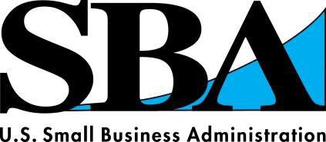

|  |  |  |  |  |
| --- | --- | --- | --- | --- |
| **Florida Presidential Disaster Declaration #15302** | | | | |
| **FEMA - 4337 - DR** | | | | |
| **Hurricane Irma** | | | | |
| **Physical Deadline: 11/9/2017** | | | | |
| **Loan Activity as of COB: 10/17/17** | | | | |
| LOAN APPLICATIONS HOME | BUSINESS | ECONOMIC INJURY (EIDL) |  | TOTAL |
| FEMA Registrations Referred 933,884 | 231,870 | 3,815 |  | 1,169,569 |
| Applications Received 51,014 | 3,918 | 2,135 |  | 57,067 |
| Applications in Process 20,663 | 2,330 | 1,143 |  | 24,136 |
| % Processed 59% | 41% | 46% |  | 58% |
| Loans Approved 2,872 | 131 | 133 |  | 3,136 |
| Dollars Approved $100,560,800 | $9,177,200 | $7,710,700 |  | $117,448,700.00 |
|  | | | | |

Puerto Rico Evacuees Task Force ‐ SITUATION REPORT No. 16 The Florida State Emergency Response Team

October 19, 2017 ‐ Published at 0800 hrs State Emergency Operations Center Activation Level: 3

|  |  |  |  |
| --- | --- | --- | --- |
| **Arrivals (Flights and Ships) Wednesday, 10/18/17** | | | |
|  | Ships | Flights | # of Passengers |
|  |  |  |  |
| **Fort Lauderdale/Hollywood Airport** |  |  | No activity reported |
|  |  |  |  |
| **Miami Intl. Airport** |  | 13 | 1,985 |
|  |  |  |  |
| **Miami‐Dade Seaport** |  |  | No activity reported |
|  |  |  |  |
| **Orlando Intl Airport** |  | 14 | 2,073 |
|  |  |  |  |
| **Port Everglades** |  |  | No activity reported |
|  |  |  |  |
| **Sandford/Orlando Int. Airport** |  |  | No activity reported |
|  |  |  |  |
| **Port of Tampa** |  |  | No activity reported |
|  |  |  |  |
| **Tampa International Airport** |  | 2 | 278 |
|  |  |  |  |
| **Total Arrivals Wednesday 10/18/2017** |  | 29 | 4,336 |
|  |  |  |  |
| **Total Arrivals since 10/03/17** | 1 | 388* | 63,060* |
| *\*Number reflects additional flight data for TPA after initial reporting on 10/17/17* | | | |

|  |  |  |  |
| --- | --- | --- | --- |
| **Relief Center Clients Served Wednesday 10/18/17** | | | |
|  | Individuals | Families | Total served |
| **Orlando Int. Airport**  **Hours of Operation: 0900‐1900** | 137 | 293 | 822 |
|  |  |  |  |
| **Miami Int. Airport**  **Hours of Operation: 0700‐2300** | 14 | 43 | 126 |
|  |  |  |  |
| **Total Clients Wednesday 10/18/2017** | 151 | 336 | 948 |
|  |  |  |  |
| **Total Clients since 10/03/17** | 1,480 | 3,197 | 11,235 |

**Finance**

Costs incurred under Host‐State Declaration FEMA‐4339‐DR‐PR Effective 10/4/2017:

|  |  |  |
| --- | --- | --- |
| **County/City** | **Costs Incurred to Date** | **Remarks** |
| Broward | No activity reported |  |
| Miami‐Dade | No activity reported |  |
| Orange | No activity reported |  |
| Seminole | No activity reported |  |
| Hillsborough | No activity reported |  |
| MIA Airport | No activity reported |  |
| MCO Airport | Expected 10/19/17 |  |
| TPA Airport | No activity reported |  |
| FDEM IMT Support | $114,907  $50,244 | Estimated – AHIMT Reg 7 Estimated – AHIMT Reg 4/6 |

**Florida FIXED Disaster Recovery Centers (by county)**

|  |  |
| --- | --- |
| Alachua County (#11) | Cone Park Branch Library  2801 E. University Ave. Gainesville, FL 32641 |
| Brevard County (#7) | Brevard County Agricultural Center 3695 Lake Dr. Cocoa, FL 32926 |
| Lee/Collier County (#4) | Bonita Springs Recreation Center 26740 Pine Ave Bonita Springs, FL 34135 |
| Highlands County | Bert J. Harris Agricultural Center  4509 West George Blvd. Sebring, FL 33875 |
| Hillsborough County (#3) | Hillsborough Community College Regent 6437 Watson Rd #101 Riverview, FL 33578 |
| Miami‐Dade County (#5) | Miami‐Dade College ‐ Kendall Campus ‐ Building “K” 11011 SW 104th St Miami, FL 33176 |
| Orange County (#8) | 2250 North Orange Blossom Trail Orlando, FL 32804 |
| Palm Beach County (#2) | Carolyn Sims Center  225 NW 12th Ave Boynton Beach, FL 33425 |
| Pinellas County (#12) | Vacant Building  2431 Tampa Rd. Palm Harbor FL 34683 |
| Polk County (#9) | W.H. Stuart Conference Center 1702 US Hwy 17 Bartow, FL 33830 |
| Putnam County (#10) | Putnam County Fairgrounds Building #1 Expo Hall 118 Fairgrounds Rd. East Palatka, FL 32131 |

|  |  |  |
| --- | --- | --- |
| **TRENDS** | | |
| **Date** | **Information** | **Location** |
| 10/16/17 | Trending concerns in order of demand: 1) Housing 2) Medication/medical 3) Food 4) Employment | ALL |

|  |  |  |
| --- | --- | --- |
| **CRITICAL ISSUES** | | |
| **Date** | **Information** | **Location** |
| 10/16/17 | Survivors are requesting lodging, food, medication, and unemployment benefits. Inquiries for long term housing assistance requests are increasing. | ALL |
| 10/16/17 | The most critical need is assisting survivors with getting referred to a partnering agency to register for food and lodging assistance. | MCO |
| 10/18/17 | Due to Homeowners Association and Rental contracts restricts, some families are unable to provide short & long term shelter for family members | MCO |

|  |  |  |
| --- | --- | --- |
| **EMERGING** | | |
| **Date** | **Information** | **Location** |
| 10/16/17 | Some survivors are not seeking assistance directly after disembarking their flights and are returning to the airport a day or two later after arriving | MIA |
| 10/16/17 | Concern that the airport welcome center will close before family members can arrive from the islands since flights are booked until the end of October. DSA referred to DRC with location and hours of operation. | MIA |

**Task Force Updates**

***Tampa International Airport***

*1st Flight 1027 from San Juan:*

Representatives from Airport Guest Services, Hillsborough County Affordable Housing, Hispanic Services Council and Veterans Administration Airport gave out 20 information packets out. The flight today had 141 passengers out of 175 seats available. There were 26 passengers requiring wheelchair assistance.

*2nd Flight 1435L from San Juan:*

Hillsborough County Social Services and Airport Guest Services gave out 32 information packets. The flight today had 137 passengers out of 150 seats available. There were 25 passengers requiring wheelchair assistance.

Hillsborough County Affordable Housing Staffing the Reception Table at Tampa International Airport 10/18/17:

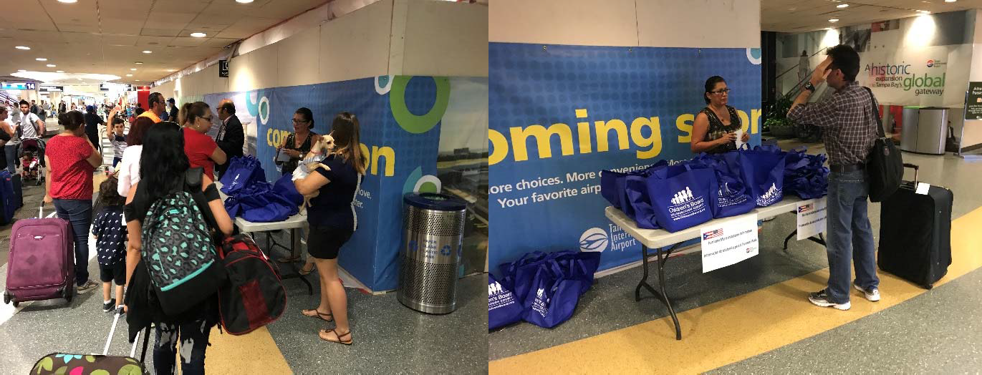

***Osceola County***

Osceola County has a reception center located at Osceola Heritage Park Exhibition Hall. Open 7 days a week from 1000 to 1600. To date the center has seen 784 families and the Osceola County School District has registered 384 students.

**Participating Agencies**

***Orlando International Airport (MCO)***

City of Orlando Hispanic Office for

* Division of Emergency Management
* Department of Agriculture and Consumer Services
* Department of Health
* Department of Children and Families
* Department of Economic Opportunity
* Department of Elder Affairs
* Department of Highway Safety and Motor Vehicles
* Osceola Health and Human Services
* Florida Licensing on Wheels – DMV Local
* Greater Orlando Aviation Authority / Orlando International Airport
* LYNX
* Orange County Family Services
* Orange County School Board

Local Assistance

* Osceola County Public School
* Veteran’s Affairs Federal
* Federal Emergency Management Agency (FEMA)
* Veteran’s Benefits Administration NGO
* American Red Cross
* United Way
* Latino Leadership, Inc.
* Catholic Charities
* Health Insurance Story
* Salvation Army
* Calvario City Church
* Aspire Health Partners, Inc.
* Shepard’s Hope
* Halo Office
* Second Harvest Food Bank

***Miami International Airport (MIA)***

**Miami‐Dade Aviation Department**

* Division of Emergency Management
* Department of Agriculture and Consumer Services
* Department of Health
* Department of Children and Families
* Department of Economic Opportunity
* SE Florida Region 7 AHIMT
* Florida Licensing on Wheels‐ DMV Local

**Miami International Airport Federal**

* Federal Emergency Management Agency (FEMA)
* Social Security Administration NGO
* American Red Cross
* Salvation Army
* Banyan Health Systems
* Catholic Charities

***Tampa International Airport***

* Hillsborough County Affordable Housing
* Hillsborough County Aviation Authority
* Hillsborough Social Service
* Hispanic Services Council
* Veterans Administration

***Osceola County (Heritage Park)***

* Osceola Community Health Services
* Park Place Behavioral Health Care
* Osceola County Human Services
* Access Community Services
* Florida Department of Health
* LYNX
* Family Physicians Group
* Valencia College
* Career Source
* Goodwill Industries
* UF Extension Services
* Osceola County School District
* Community Hope Center
* New York Life Insurance
* Osceola Tax Collector’s Office
* Angels For Kids
* In Health Medical Alliance